**Class:** Final Year (Computer Science and Engineering)

**Year:** 2021-22 **Semester:** 1

**Course: High Performance Computing lab**

**ESE Exam**

**22/11/2021 01.00 PM – 04.00 PM**

**Exam Seat No:**

Name: Rutuja Shivaji Patil

Exam Seat Number: 2018BTECS00018

**Problem Statement 1**

**Statement: Write an OpenMP program to print inverted pyramid using *.**

**Screenshot 1:**

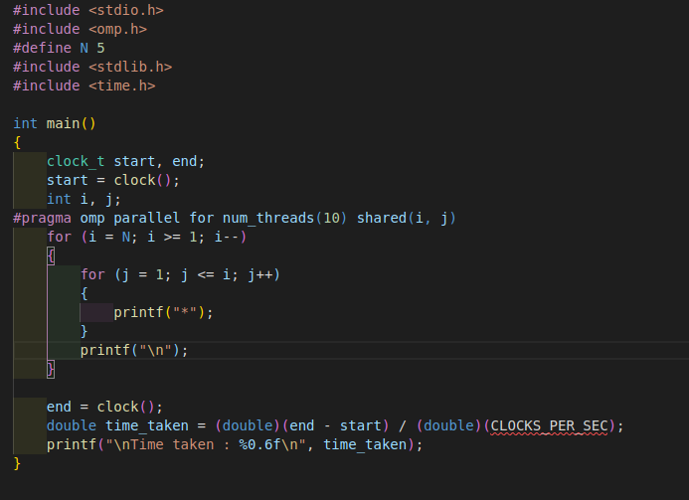

**Information 1: Program for inverting pyramid using openmp**

**Screenshot 2:**

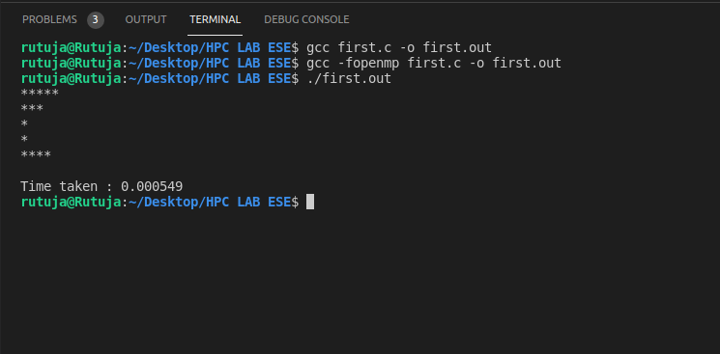

**Information 2:output**

**Problem Statement 2**

**Statement: Implement MPI program to reduce the data from n processes to root process.**

**Screenshot 1:**

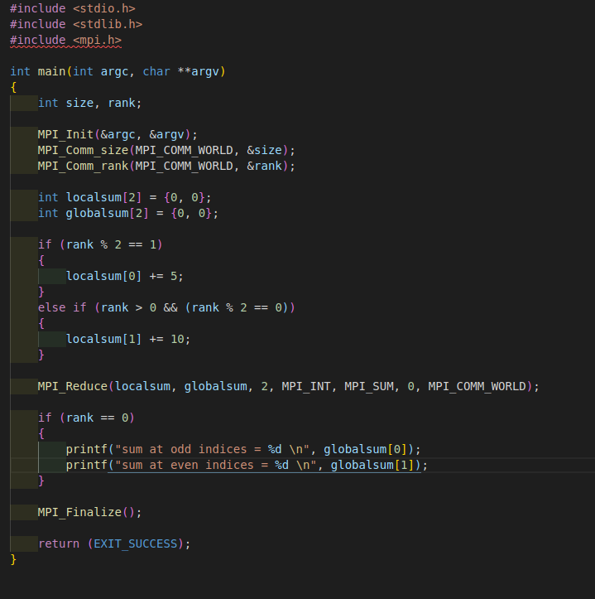

**Information 1: Program**

**Screenshot 2:**

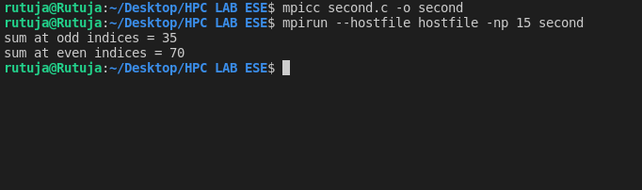

**Information 2: output**

**Technologies Used: openmp,mpi**

**GitHub Link: https://github.com/rutuja-patil107/HPC_ESE**